AZERBAIJAN REPUBLIC

MINISTRY OF TRANSPORT

“AZERROADSERVICE” OPEN JOINT STOCK COMPANY

AZERBAIJAN MOTORWAY IMPROVEMENT
AND DEVELOPMENT
Baku – Shamakhi Road Widening

RESETTLEMENT POLICY FRAMEWORK (RPF) FOR BAKU-SHAMAKHI ROAD WIDENING PROJECT

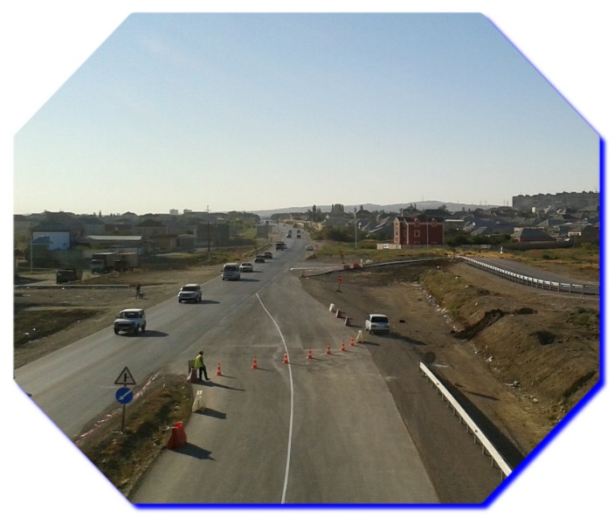

November 2015

Table of Contents
List of Tables 3
Acronyms 4
Definition of Terms 5
1.0 PROJECT DESCRIPTION 6
1.1 Background 6
1.2 Rationale for Preparation of the Resettlement Policy Framework (RPF) 7
1.3 Objectives of the Project Resettlement Policy Framework (RPF) 7
1.4 Involuntary Resettlement Requirements under the World Bank Involuntary Resettlement Policy (OP 4.12) 9
2.0 LEGAL FRAMEWORKS 9
2.1 National Legal Framework 10
2.2 Analysis of different provisions and their mutual application 11
3.0 GUIDING PRINCIPLES FOR RESETTLEMENT: 12
3.1 Compensation and Eligibility Principles: 12
3.1.1 Eligibility 13
Entitlement to Compensation and Cut-Off Date 13
3.1.2 Compensation Entitlements: 13
4.0 METHODS AND PROCEDURE FOR VALUATION OF ASSETS AND ENTITLEMENT MATRIX 16
5.0 GENDER IMPACT AND MITIGATION MEASURES 17
6.0 ORGANIZATIONAL RESPONSIBILITIES & INSTITUTIONAL FRAMEWORK 17
6.1 Azer Road Service Open Joint-Stock Company (ARS OJSC) 17
6.2 ARS-Land Acquisition Division (ARS-LAD) 17
6.2.1 Supervision Consultant (SC) 17
6.2.2 Local Governments 17
6.2.3 Civil Works Contractor 17
6.2.4 Local Team 17
7.0 FUNDING FOR RESETLEMENT ACTION PLAN (RAP) 17
8.0 PUBLIC PARTICIPATION/CONSULTATION 17
9.0 COMPLAINTS & GRIEVANCES 17
10.0 MONITORING AND SUPERVISION 17
10.1 Internal Monitoring 17
10.2 External Monitoring 17
11.0 RESETTLEMENT PLANNING: 17
12.0 DISCLOSURES 17
Appendix I 17
Outline of a Resettlement Plan 17
Appendix II 17
PIU for World Bank Funded Roads / Highways Projects 17
Appendix III 17
List of People Consulted During Development of the RPF (2015) 17
Appendix IV 17

List of Tables

Table 1: Comparison of Azerbaijan Laws on Land Acquisition & Involuntary Resettlement and WB’s OP 4.12* 11
Table 2: Entitlement Matrix 17

Acronyms

AP | Affected Person
aRAP | Abbreviated Resettlement Action Plans
ARS OJSC | Azer Road Service Open Joint-Stock Company
ARS-LAD  AP | Azer Road Service-Land Acquisition Department  Affected Person
ARS-PIU | Azer Road Service- Project Implementation Unit
CA | Control Authority
CBOs | Community Based Organizations
EA | Expropriation Authority
GoA | Government of Azerbaijan
GRC | Grievance Redress Committees
GRM | Grievance Redress Mechanism
IBRD | International Bank for Reconstruction and Development
IDPs | Internally Displaced People
LAD | Land Acquisition Division
LALSN | Law on Acquisition of Lands for States Needs
LAR | Land Acquisition and Resettlement
MoF | Ministry of Finance
NGO | Non-Government Organization
OJSC | Open Joint-Stock Company
OP | Operational Policy
PAP | Project Affected People
PIU | Project Implementation Unit
PIU-ARS | Project Implementation Unit-Azer Road Service
RAP | Resettlement Action Plan
RPF | Resettlement Policy Framework
SC | Supervision Consultant
SCPI | State Committee on Property Issues
SIA | Social Impact Assessment
WB | World Bank

Definition of Terms

Compensation  Consultant | Payment in cash or in-kind for an asset to be acquired or affected by a Project at replacement cost at current market value.  Design Consultant on behalf of Ministry of Transport
Cut-off-date | The date when Census, inventory of affected assets and socioeconomic survey for the entire Project started is considered to be a cut-off date for the project.
Detailed Measurement  Survey | The detailed survey of project affected land parcels and inventory of affected assets.
Entitlement | The range of measures comprising cash or kind compensation, income rehabilitation assistance, transfer assistance, income substitution/business restoration, which are due to APs, depending on the type, extent and nature of their losses, and which suffice to restore their social and economic base.
Land acquisition | Process whereby a person is compelled by a public agency to alienate all or part of the land she/he possesses, to the ownership and possession of that agency, for public purposes, in return for compensation.
Non-titled | Physical persons who have no recognizable rights or claims to the land that they are occupying and includes people using private or state land without permission, permit or grant, i.e. those people without legal title to land and/or structures occupied or used by them.
Project Affected Persons (PAPs) | All the people affected by the Project through land acquisition, relocation, or loss of incomes and includes any person, household (sometimes referred to as Project affected family), firm, or public or private institution. PAPs therefore include;( i) persons affected directly by the road corridor, right-of-way, tower or pole foundations or construction work area; (ii) persons losing privately owned or used buildings and structures (residential dwellings and supplementary structures); (iii) persons whose agricultural land or other productive assets such as trees or crops are affected; (iv) persons whose businesses are affected and who might experience loss of income due to the Project impact; (v) persons who lose work/employment as a result of Project impact; and (vi) people who lose access to community resources/property as a result of the Project.
Replacement cost (structures) | With regard structures, "replacement cost" is the market cost of the materials to build a replacement structure with an area and quality similar to or better than those of the affected structure, or to repair a partially affected structure, plus the cost of transporting building materials to the construction site, plus the cost of any labor and contractors' fees, plus the cost of any registration and transfer taxes. In determining the replacement cost, depreciation of the asset and the value of salvage materials are not taken into account, nor is the value of benefits to be derived from the project deducted from the valuation of an affected asset.
Replacement cost (land) | With regard to agricultural land "replacement cost" is the pre-project or pre-displacement, whichever is higher, market value of land of equal productive potential or use located in the vicinity of the affected land, plus the cost of preparing the land to levels similar to those of the affected land, plus the cost of any registration and transfer taxes.  For land in urban areas, it is the pre-displacement market value of land of equal size and use, with similar or improved public infrastructure facilities and services and located in the vicinity of the affected land, plus the cost of any registration and transfer taxes.
Sharecropper | Same as tenant cultivator or tenant farmer, i.e., a person who cultivates land they do not own for an agreed proportion of the crop or harvest.
Severe impact | Project impact causing the loss of 20 % or more of project affected assets that may cause long-term hardship and impoverishment of PAP.
Vulnerable | Those living below the poverty line, the elderly, women and children.

RESETTLEMENT POLICY FRAMEWORK

  - PROJECT DESCRIPTION

1.1 Background
The Government of Azerbaijan (GoA) has received a loan from the International Bank for Reconstruction and Development (IBRD) in connection with the Azerbaijan Third Highway Project. The Project is co-financed by the Government of Azerbaijan.

The Baku-Shamakhi road is part of the M4 road which connects Baku with Yevlakh in central Azerbaijan, and is a reasonable alternative route to the M2 between Baku and Yevlakh for lighter vehicles. The Baku-Shamakhi road is a section of the shortest way from Baku to Georgia and to western Azerbaijan. The construction works for upgrading the entire length of Baku-Shamakhi road are on-going.

Presently, the Government of Azerbaijan intends to use funding from this loan towards the consultancy services on the environmental assessment of km 13.5 to km 15 section of Baku-Shamakhi road, updating of current Resettlement Policy Framework for Baku – Shamakhi road widening project prepared in 2009 (Sections km13.5-15, km91-116 and km121.4-121.7), assessing incremental environmental and social impacts of changed scope of construction works for section from km 45 to km 91 of Baku-Shamakhi road, 2013, updating of EIA and EMP of km 91 to km 107 of Baku-Shamakhi road according to the changes in the alignment.

A new cross-section will be provided within km 13.5 to 15, which includes a dual 4-lane road and two side roads, one on each side of the new dual carriageway. The cross-section has been reduced from the standard width of 27.5m to a min of 20.0m. This has been achieved by means of reduced median from 5 m to a min 3 m and reduced hard-shoulder from 3.75 m to min 1m. The reduced cross-section has permitted the provision of two additional lanes, one on each side of the new dual carriageway, for local access to adjacent properties and side roads. Most of the road dualling follows the existing road alignment and therefore the existing culverts under the carriageway will be extended to accommodate the road widening.

Two new footbridges are provided within km 13.5 to 15 for crossing the dual carriageway where the bus stops are located. The highway drainage along this section will mainly consist of a “Closed Concrete Channel” receiving runoff from the road surface and positioned at the edge of the pavement on both sides of the new carriageway.

In the meantime the Consultancy companies are working on the Detailed Design for upgrading of the road sections between km 13.5 and km 15, km 91 and km 116 and the road section between km 121.4 and km 121.7 to four lane standards. The RPF will cover all these sections. Construction works of these sections will result in involuntary land acquisition. RAPs shall be prepared by local and international consultants, contracted by the Design Engineer, under the policies and procedures set out in this Resettlement Policy Framework.

This Resettlement Policy Framework (RPF) has been designed to provide policies and procedures to ensure that the Projects are implemented in compliance with Azerbaijan’s legislation and the World Bank Operational Policy 4.12 in terms of involuntary land acquisition. During project implementation, site-specific Resettlement Action Plans (RAP) will be prepared in line with the requirements of this RPF. Measures to ensure sufficient public participation and disclosure will be implemented in line with the requirements of this RPF and the World Bank Disclosure Policy.

1.2 Rationale for Preparation of the Resettlement Policy Framework (RPF)
The World Bank policy requires screening of all projects proposed for World Bank financing to ensure that these projects are environmentally and socially sound and sustainable. While reviewing the Project site and design drawings it was found that implementation of the Project would result in mainly economic displacement of the Project Affect People (PAP), although very minimally. The PAP comprise those people who are directly affected both socially and economically by the World Bank-assisted investment Project, as a result of involuntarily taking of land and other assets resulting in:
- Relocation or loss of housing.
- Loss of assets or loss of access to assets.
- Loss of income or means of livelihood irrespective of the need for physical relocation.

This RPF has been prepared with the objectives of addressing impacts that may result from the implementation of these particular projects; thus, by definition does not address other Bank financed projects in the region.

The objectives of the assignment are:
- To prepare a Resettlement Policy Framework (RPF) to outline overall resettlement principles and objectives;
- To set out the policies and procedures for the delivery of entitlements; implementation process; grievance redress mechanisms and arrangements for independent monitoring for land acquisition and resettlement that may occur as the result of the Project.

1.3 Objectives of the Project Resettlement Policy Framework (RPF)
The operational objective of the framework is to restore the livelihood of PAP, at least to the pre-project level. In addition to Azeri legislation, the principles of the World Bank’s Operational Policy 4.12 on involuntary resettlement will be respected in preparing this Resettlement Policy Framework. In this regard, the following key principles and objectives should be applied:
- Involuntary resettlement should be avoided where feasible, or minimized, exploring all viable alternative project designs.
- Minimization of expropriation of land: The expropriation of private land should be carried out only in cases where there is no alternative;
- Legal process will be obligatory: All expropriations must be carried out according to the provisions of Azerbaijani Law and World Bank rules and regulations;
- Compensation and eligibility principles: Whenever expropriation of private property is unavoidable, such cases will be handled according to Azerbaijan law and World Bank regulations;
- Methods and procedures for evaluating assets: Details of planned acquisition to be outlined in the Resettlement Action Plans (RAP) /Abbreviated resettlement Action Plans (aRAP). The projects’ land acquisition and resettlement impacts will be guided by Abbreviated Resettlement Action Plan (aRAP) if number of people to be impacted is less than 200 persons. The relevant office for legislation and compensation, in cooperation with PIU will ensure that Resettlement Action Plans conform to the requirements of both Azerbaijan laws and World Bank policies;
- Entitlements: Entitlements will vary according to land types, assets and resources and who occupies the land such as owners, tenants, and Project Affected People (PAPs) with and without occupancy rights, people who use the land for commercial purposes; people who have made improvements of any nature; years of occupancy etc.;
- Organizational responsibilities and institutional framework: Detail on the overall responsibility for implementation and enforcement of the Resettlement Policy Framework and for planning and implementing RAP. The process of delivery of entitlements shall describe in detail, noting who is involved at each stage;
- Funding for implementing Resettlement Action Plans: RAPS will clearly describe responsibility and process for financing (based on the cost estimated and presented in the RAP);
- Public participation and consultation: Ensure that PAPs participate in the project throughout various stages of the planning and implementation of the RAP. Prior to the preparation of the RAP, the PAPs will be informed of the provisions of the Resettlement Policy Framework at public meetings and information will be publicly disclosed. Each PAP will be fully informed of their entitlements and rehabilitation choices as outlined in the RPF/RAP;
- Complaints and grievances: Based on the legislation of Azerbaijan Republic, grievances will be received and redress mechanisms will be applied to ensure that all grievances of the PAPs are dealt with fairly. Particular attention shall be given to women and vulnerable groups. During monitoring, all grievances and resolutions made by PAPs are recorded to ensure that these grievances are addressed in a timely manner;
- Monitoring and supervision: A monitoring mechanism will be in place to supervise implementation of the RAP. Whenever considered necessary an independent specialist will be contracted to carry out external monitoring and evaluation of the implementation of RAP. Besides gathering information on project’s socio-economic impact, to measure changes off the baseline data collected, the external monitor will gather information on project’s socio-economic impact on the PAPs and suggest modifications, if any, in the implementation procedures of the RAP to achieve the desired objectives of the RPF;
- Resettlement planning: The RAP include detailed socio-economic surveys of the PAPs to cover their age, sex, ethnicity, education & occupation, estimates of household expenditure patterns, livelihood skills, and record of fixed and moveable assets. As a part of the socio-economic survey, the team will be advised to establish measurable indicators on livelihood restoration for PAP monitoring and evaluation purposes.
- Disclosure: In addition to the consultation process, and in accordance with the World Bank Policy on Access to Information, the RPF and RAP will be made available locally in Azeri once they are approved and before the start of any acquisition (land, assets) or expropriation activities.

The RPF applies to all persons affected by the project regardless of the severity of impact and whether or not they have legal title to land or other assets.

The site-specific Resettlement Action Plans (RAP) will be prepared by international and local consultants hired by the Design Engineer and approved by the World Bank, and implemented, prior to the commencement of civil works. The RAP will detail the package of compensation and rehabilitation measures eligible for PAP, as defined by this RPF and Bank OP 4.12. Land-take and taking of related assets can take place only after all compensation and rehabilitation measures, defined in the relevant RAP, have been provided to eligible PAP. In the event that some PAPs need to be physically relocated, particular attention will be paid to ensure that their livelihoods are at least restored to the pre-project level. Particular attention will be paid to the needs of vulnerable groups among those displaced, especially those living below the poverty line, the elderly, women and children. An outline of RAP is presented in Appendix I.

1.4 Involuntary Resettlement Requirements under the World Bank Involuntary Resettlement Policy (OP 4.12)
The World Bank Policy on Involuntary Resettlement is based on the following principles:
- Involuntary resettlement should be avoided where feasible, or minimized, exploring all viable alternative project designs.

- Where it is not feasible to avoid resettlement, resettlement activities should be conceived and executed as sustainable development programs, providing sufficient investment resources to enable the persons displaced by the project to share in project benefits. Displaced persons should be meaningfully consulted and should have opportunities to participate in planning and implementing resettlement programs.

- Displaced persons should be assisted in their efforts to improve their livelihoods and standards of living or at least to restore them, in real terms, to pre-displacement levels or to levels prevailing prior to the beginning of project implementation, whichever is higher.

- LEGAL FRAMEWORKS

2.1 National Legal Framework
In Azerbaijan several legal codes and Acts regulate issues related to expropriation of private lands for the State needs. Article 29 of the Constitution of Azerbaijan (12 November, 1995) establishes the right of citizens to possess property and protection of their property rights. It also ascertains that no one is dispossessed of land without appropriate Court safeguards, and that alienation of property for State needs shall only be allowed upon fair reimbursement of the market value of the asset in question.

A Law on Acquisition of Lands for State Needs (LALSN) was passed on 20 April, 2010 that provides a detailed procedure of acquiring the lands for state needs; calculating the amount of compensation; rules of paying this compensation as well as stipulates other relations between the parties relating to the land acquisition. Prior to the enactment of this Land Acquisition Act, there were no laws or legislation in Azerbaijan that specifically addressed matters of involuntary resettlement. However, besides this new legislation, a few regulatory instruments already exist in the country that provide the basis for regulating and managing the acquisition of land, properties and productive assets and for compensation for the loss of these assets. They are as follows:
- The Civil Code (01 December 1998): This Civil Code states that any rights to immovable properties must be registered with the state, and that land may be recalled from owners for state needs by payment of compensation equal to market cost of the acquired land
- Land Code (25 June 1999): According to this Code, when land is required for projects of state needs, compensation is initially offered on the basis of valuations made in accordance with a standard code of 1998. If landowners are unhappy with this valuation, there is scope for agreeing on a revised valuation. In the event that such agreement cannot be reached, the acquiring authority can process its application for acquisition through the courts, i.e. expropriation.
- Law on Land Reform (1996) & Law on Land Market (1999): These laws stipulate that ownership, use and renting rights of owners on lands may be sold or bought only upon their personal consent and through land auctions.
- Presidential Decree (23 October 2003, N972) - On Additional Steps Relating to Implementation of Law “On Land Rent” and approving the Rules about the running of auctions relating to the allocation (ownership or renting) of state or municipality lands: These normative acts provide that the lands which are in state ownership may be allocated to ownership or rent through auctions by the decision of local executive power.
- Cabinet of Ministers Resolution N158 (1998) – On Establishment of New Normative Prices for Land in the Republic of Azerbaijan: Establishes the normative or cadastral rates for lands in each district.
- Cabinet of Ministers Resolution N110 (1999) – On Approval of Regulations for an Inventory Cost Estimation of Buildings Owned by Natural Persons: This resolution outlines procedures for acquisition and compensation valuation for affected buildings and immovable properties. It refers to the standard code No. 58 that is to be used for making valuations of land and property to be acquired. These valuations are made on the basis of standard unit rates for different types of construction in different regions of Azerbaijan.
- Cabinet of Ministers Resolution No. 42 (2000) – On Some Normative and Legal Acts relating to the Land Code of the Republic of Azerbaijan: This resolution outlines procedures for the compulsory acquisition of land for state needs.
- Decree on application of the Road Law (2000) & Decree on Additional Activities for Regulating the Use of Road Reserves (2004): Both laws are applicable to all roads related activities in Azerbaijan.
- Decree of the President (26 December 2007): Ensures execution of the law No. 506-3 QD dated 7 December 2007 on “Amendments and Additions to the Civil Code of the Azerbaijan Republic” requires the provision of 20% additional compensation to the calculated market price of the acquired property to compensate for the damages resulting from the purchase of property, including income loss connected with the pre-termination of commitments against third parties.

2.2 Analysis of different provisions and their mutual application
Many provisions of the World Bank’s OP 4.12 requirements are covered under national legislation of Azerbaijan but there remain differences, as presented in Table 1 as below:

Table 1: Comparison of Azerbaijan Laws on Land Acquisition & Involuntary Resettlement and WB’s OP 4.12*
Sl No | Azerbaijan Laws and Regulations | WB OP 4.12
 | Compensation to title holders; tenant with legal rights; legal long-term occupants including renters. Resettlement assistance for non-title holders | Lack of title should not be a bar to compensation and/or rehabilitation. Non-titled landowners receive rehabilitation and assistance.
 | Compensation to be determined based on market value as well as replacement value. In case both principles are applicable, the one that provides larger compensation will be applied. (Article 55.2, 58 & 59 of LALSN, 2010). As per the Decree of the President of Azerbaijan, an additional 20% compensation amount shall be paid to cover additional costs | Compensation for affected structures and land should be based on replacement cost. Depreciation is not considered in the valuation of structures.
 | Under the national legislation (LALSN, 2010), in cases where the number of people to be relocated 100 metres away from their land exceeds 200, a resettlement plan is to be prepared. In other cases, only a resettlement manual will be prepared. | RAP/aRAP will be prepared in line with the provisions of the World Bank OP 4.12. In particular, a census, socio-economic survey and consultation with PAP will be conducted while preparing a RAP and its implementation will be monitored and reported, irrespective of numbers of people affected.
 | Grievance Commission (Article 75 of LALSN, 2010) to be appointed in large scale projects in case of necessity. The Executive Agency, Land Acquisition Group, Control Agency, local Executive Power, municipalities and CSC are able to receive, consider, and solve grievances and complaints. | Appropriate and accessible grievance mechanisms are established for affected groups.
 | No additional provisions for income rehabilitation, allowances for severely affected or vulnerable APs considered. | Displaced persons should be assisted in their efforts to improve their livelihoods and standards of living or at least to restore them, in real terms, to pre-displacement levels or to levels prevailing prior to the beginning of project implementation, whichever is higher. In addition, “particular attention is paid to the needs of vulnerable groups among those displaced, especially those below the poverty line, the landless, the elderly, women and children, indigenous peoples, ethnic minorities, or other displaced persons who may not be protected through national land compensation legislation”
 | Public meetings are to be conducted to discuss land expropriation proposal at the preparatory stage. | Public consultation and participation is the integral part of WB’s policy which is a continuous process at conception, preparation, implementation and post implementation period.
*Instances where there are discrepancies between the two – gaps as identified, the project will follow the World Bank Resettlement Policies and procedures.

3.0 GUIDING PRINCIPLES FOR RESETTLEMENT:
The principles of the World Bank’s Operational Policy 4.12 on involuntary resettlement and relevant Azeri legislation will be respected in this Resettlement Policy Framework. In this regard, the following key principles of resettlement will be applied:
- Minimization of acquisition of land: The acquisition of private land will be carried out only in cases where there is no alternative;
- Legal process is obligatory: All acquisitions must be carried out according to the provisions of Azeri Law and World Bank rules and regulations;
- Compensation and eligibility principles: whenever acquisition of private land is unavoidable, then such cases will be handled according to Azerbaijan law and World Bank regulations.
Apart from these key principles, following steps will be taken to ensure transparency and fairness:
- Compensation for land and other affected assets will be provided at replacement cost. Replacement cost is defined as follows: For agricultural land, it is the pre-project or pre-displacement, whichever is higher, market value of land of equal productive potential or use located in the vicinity of the affected land, plus the cost of preparing the land to levels similar to those of the affected land, plus the cost of any registration and transfer taxes. For land in urban areas, it is the pre-displacement market value of land of equal size and use, with similar or improved public infrastructure facilities and services and located in the vicinity of the affected land, plus the cost of any registration and transfer taxes. For houses and other structures, it is the market cost of the materials to build a replacement structure with an area and quality similar to or better than those of the affected structure, or to repair a partially affected structure, plus the cost of transporting building materials to the construction site, plus the cost of any labor and contractors' fees, plus the cost of any registration and transfer taxes. In determining the replacement cost, depreciation of the asset and the value of salvage materials are not taken into account, nor is the value of benefits to be derived from the project deducted from the valuation of an affected asset.
- Clear procedure to determine compensation for temporary loss of land/ assets during construction and permanent acquisition of land and assets;

3.1 Compensation and Eligibility Principles:
The land acquisition and resettlement tasks in this project will be carried out according to the compensation eligibility and entitlement provisions developed in line with the Azeri laws and the World Bank Policy 4.12.

3.1.1 Eligibility
Under this project, following affected persons will be eligible for compensation and rehabilitation assistance.
- Persons losing land and other assets with legal title/traditional land rights
- Persons losing land under valid legal rights, and
- Persons losing land without legal status are eligible to be compensated for loss of structures, perennial crops, etc. sited on the land, but not the land

Entitlement to Compensation and Cut-Off Date

Compensation eligibility will be limited by a cut-off date to be set for each subproject. The date when Census, inventory of affected assets and socioeconomic survey for the entire Project is started is considered to be a cut-off date for the project. The improvements made to structures after the cut off date and persons who settle in the affected areas after the cut-off date will not be eligible for compensation.

Potentially affected persons will be clearly informed of the cut-off date and its implications. Ways in which they will be informed include letters to individual affected persons and public notices aimed at the broader community and at reaching any unidentified PAPs.

3.1.2 Compensation Entitlements:
Compensation will include provisions for permanent and temporary land losses; house and buildings losses; crops and trees losses; a relocation subsidy; and a business losses allowance based on tax declarations and/or a lump sum. Details of these entitlements are presented below:
- Private and agricultural land: Affected persons with legal title/traditional land rights will be compensated at replacement cost (see definition in Section 3.0) in cash or through replacement of land equal in value/productivity to the plot lost. In line with replacement cost, any transfer taxes/fees will not be paid by the affected person but will be paid by the executing agency or will be waived by local governments. Based on the decree of the President of Azerbaijan Republic, an additional 20% of compensation amount will be paid to cover additional costs.
In case residential land (in towns, suburban and rural areas) – Compensation will be provided at replacement cost (see definition in Section 3.0). In line with replacement cost, the plot should have the same or improved public infrastructure in the adjacent area.
In case of agricultural land – in line with replacement cost, compensation will include cost for improving the quality of the land similar to the condition of the affected land, and fees and taxes for the transfer of land title will not be borne by the affected person.
- Residual agricultural land: Residual portions of plots affected by the required right-of-way that are reduced or rendered unusable by alterations in access, irrigation, or workability will be included in the affected land and compensated as per provisions made above.
- Loss of income (from crops): Affected person’s (owners, leaseholders, sharecroppers, and squatters) income from land, if affected, then s/he will get cash compensation equivalent to cash compensation at current market rates for the gross value of 1 year’s harvest losses.
- Residential/commercial land: Legal settlers and title holders will be compensated at replacement cost (see definition in Section 3.0) either in the form of land for land or cash at current market rates, free of transaction costs and depreciation. . Based on the decree of the President of Azerbaijan Republic, an additional 20% of compensation amount will be paid to cover additional costs.
- Houses, buildings and structures: will be compensated in cash at full replacement cost free of deductions for depreciation, salvaged materials, and transaction costs irrespective of the registration status of the affected item. Based on the decree of the President of Azerbaijan Republic, an additional 20% of compensation amount will be paid to cover additional costs.
- Loss of crops: in case if harvesting of seasonal crops is not possible cash compensation at current market rates for the gross value of 1 year’s harvest losses. Crop compensation will be paid both to landowners and tenants based on their specific sharecropping agreements. Based on the decree of the President of Azerbaijan Republic, an additional 20% of compensation amount will be paid to cover additional costs.
- Trees and standing crops: The construction schedule will be planned so farmers will be able to harvest the annual crops. In the event that the schedule cannot be adjusted and some loss of crops becomes inevitable, compensation based on the replacement value will be provided. Annual crops will be valued at full market rate. Cash compensation for affected fruit trees will be calculated at current market value and according to type, age, and productive value of project affected fruit tree. Annual yield capacity of a mature fruit-bearing tree multiplied to market price of a fruit (kg/AZN) and multiplied to the number of years required to grow a new tree to same productivity age. Construction Company ensures free delivery of timber of all logged down perennials to the residence of PAPs and PAPs will be eligible to dispose logged trees themselves. Based on the decree of the President of Azerbaijan Republic, an additional 20% of compensation amount will be paid to cover additional costs
- Businesses: If business is lost permanently it will be compensated in cash equal to a 1-year income based on tax declaration or, if unavailable, based on the official minimum salary; temporary business losses will be compensated in cash for the business interruption period based on tax declaration or, if unavailable, official minimum salary.
- Business workers and employees: Indemnity for lost wages for the business interruption period in case of temporary stoppage of business is considered. In case of permanent loss of business wages for 3 month will be paid .
- Agricultural land leaseholders, sharecroppers, and workers: Affected leaseholders with not utilized lease period will be paid back the remained period of lease and new plot will be proposed in obtaining a new lease. Leasing costs and lost income will be compensated.
- House renters: House renters who have taken a house on lease for residential purposes will be provided with a cash grant of 3 month’s rent at the prevailing market rate in the area and will be assisted in finding alternative accommodation.
- Squatters: The squatters, whose livelihoods are affected, will be provided with livelihood restoration support, based on the social survey undertaken as part of the RAP preparation and detailed in the RAP, resettlement assistance, and compensation for lost structures and other assets as detailed above.
- Community structures and public utilities: These assets will be fully relocated or rehabilitated so as to meet their pre-project functions and utilities.
- Temporary impacts during construction: The civil works contract will require the contractor to be responsible for the temporary acquisition and reinstatement of all land required outside the road reserve (ROW) for construction camps, offices, borrow pits, materials storage sites, materials processing sites and haul roads. The contractor will select the land parcels they require and they will be responsible for negotiating agreements with land owners to occupy the land. In the event that a contractor fails to obtain the agreement of any landowner, he would be required to select an alternative site and negotiate a new agreement. After construction the land will be returned by the contactor to its original condition before transfer back to affected person. No involuntary occupation of land for the construction of camps, offices, borrow pits, materials storage sites, materials processing sites, and haul roads would occur. Provision will be made in the civil works contract for the contractor to be responsible for providing adequate measures to cater for existing traffic while the road/bridge rehabilitation/construction works are in progress. The contractors shall be required to obtain the approval of the executing agency for all proposals for traffic management during the construction of the civil works contracts and they shall also be required to maintain all temporary diversion roads and existing roads used to carry diverted traffic from the main road.
- Severely affected people – PAP losing more than 20% of income generating land, or assets, or livelihood in general will have priority in involvement in to the road construction activities accordingly to their abilities. The list of these severely PAPs will be provided by the Design Engineer to the Executive Agency as a result of RAP preparation study and forwarded to the Construction Company for consideration. PAPs will also be informed of the mentioned opportunity during public consultation for further proceeding for job application.
- Vulnerable groups: Capable family members of project affected vulnerable groups will be given priority in employment in project-related jobs to be assisted with their livelihoods restorations. Other needs of the project vulnerable groups will be identified during the socio-economic survey/census to be prepared as part of RAP preparation. The measures shall be detailed in the RAP
- Escrow/deposit accounts. In case missing, absent PAPs are identified during census, demarcation and Detailed Measurement Survey (DMS) Cash compensation at replacement cost of these project affected structures and lands will be deposited to the escrow accounts. However, no other one-time allowances will be allocated to this project affected units. The procedures for exercising escrow account, the list of documents to be presented to receive amount of cash compensation deposited on escrow accounts will be described in the final RAP.
- Taxation: In accordance to article 81 of the LASLD, in no case will the PAPs be liable for any taxes or eventual transaction fees; these will be paid by the implementing agency unless waived by the government of the RoA.
Bank Service Fee: Besides, all bank service fees will be covered by the EA.

4.0 METHODS AND PROCEDURE FOR VALUATION OF ASSETS AND ENTITLEMENT MATRIX
All land and structures are to be compensated based on replacement cost. The methodology for assessing unit compensation values of different items will be as follows:
- Agricultural land will be valued accordingly to two principals as per provisions of the Law on Acquisition of Lands for State Needs.
- Market cost of the land is calculated based on the active land markets (article 58)
- In case active land markets do not exist for identification of market value of the land it will be compensated based on the replacement cost. The replacement costs will be determined by the Independent Appraisal (to be assigned in the RAP implementation stage by the MOF) Specialist based on the cost required for procurement of the land with the same status, quality, size and productivity in the vicinity of the impacted land (article 59). In case both of these principles are applicable, the one that provides higher cost will be applied.
- Houses/buildings will be valued at market price based on construction type, cost of materials, type of construction, labor, transport and other construction costs. Compensation will be calculated at replacement cost (see definition in Section 3.0). Therefore, no deduction for depreciation and transaction costs will be applied. Physical relocation of households is not anticipated under this Project, and buildings and structures used for dwelling would not be impacted. If such impacts prove to be unavoidable under the final designs, these structures will be compensated based on replacement cost. Loss of or damage to farm outbuildings, fences, walls and other impacted structures will be compensated based on the replacement cost. Cash compensation will be available as a preferred option for structures, such as extra buildings lost, that are not the main house or house in which some-one is living.
- Annual crops. In case the construction schedule does not allow harvesting of annual crops and crop loss becomes inevitable, the lost crops will be compensated.
- The formula used for calculating compensation for annual crops is as follows:
CrC = ((RP x Yd) – CC) x A x T
CrC = compensation for loss of income from annual crops; RP = retail price of the produce (Azeri Manat/100 kg); Yd = yield (100 kg/hectare); CC = growing costs including material inputs, agro-technical activities, transportation, taxes and duties (Azeri Manat/hectare); A = area cleared by the project (hectares) and T = number of lost growing seasons.
- Trees will be valued according to different methodologies depending whether the tree lost is having only timber value or a fruit-bearing one.
Trees having timber value will be assessed based on (a) age category (a) seedling; (b) medium growth and (c) full growth (d) timber value and (e) volume.
Fruit-bearing/productive trees will be valued based on (a) age (b) seedling (c) adult-not fruit bearing and (d) fruit bearing. Stage (d) trees will be compensated at net market value of 1 year income multiplied by number of years needed to grow a tree to the similar productive age.
The unit value of compensation will be initially assessed by project consultants and finally evaluated by the authorized independent evaluator based on clear and transparent methodologies acceptable to the executing agency. The assessed compensation rates will then be verified and certified by the relevant government authority.
- Temporary impacts: Compensation for temporary impacts during construction will cover the following components:
  - Loss of annual crop production
  - Loss of any trees or perennial crops
  - Loss of immovable assets and land attachments
Upon completion of construction, the land used for temporary access roads will be reinstated to its pre-project condition and returned to the owner or user.
- Residential/Commercial Land: Legal settlers will be compensated at replacement cost (see section 3.0 for definition) either (i) in form of land for land, or (ii) cash. Renters/leaseholders will be proposed a renewal of the lease in other plots. They will also be compensated for any improvements made on the land. Squatter settlers will be rehabilitated through provision of compensation for any construction/ structures and improvements made on the land, except from land. Besides, squatters will be provided one time relocation allowances for covering transportation expenses.
- Loss of livelihoods: Financial and other assistance will be provided to the affected persons whose livelihoods will be lost by taking period of transition in to consideration. The Executive Agency will provide information assistance to PAPs to address all concerns related with the new community, possible job applications, available job/ income generate opportunities, available socio-economic services around, communal infrastructure and social services available around that will assist in their restoration of livelihood and living standards after resettlement. Moreover, during preparation of the RAP the Consultant will carry out additional socio-economic analysis, including interviews with affected people to identify potential skill based training needs and define effective and available capacity building activities to enhance livelihood conditions. Priority training needs and capacity building measures will be reflected in the RAPs.
- Community structures and public utilities: will be fully replaced or rehabilitated so as to satisfy their pre-project functions.
- Vulnerable people’s livelihood: Vulnerable people (those living below the poverty line, the elderly, women) will be given priority in employment in project-related activities.

4.2 Entitlement Matrix:
The compensation and rehabilitation entitlements for each affected item are presented in Table 2.
Table 2: Entitlement Matrix
Sl No | Type of Loss | Application | Entitled Person | Compensation Measures | Policy Basis | Responsible Agency
 | Permanent loss of private land | Agricultural, residential and commercial land | Land owner | Compensation at replacement cost. Land with same size, quality and production value for the lost land. In case of agricultural land, same size, quality and production value for the lost land. Replacement cost is defined in Section 3.0. Plus an additional 20% according to Presidential Decree dated 26, 12, 2007. Any other compensation, as agreed between affected people and expropriation authority. | Law on Acquisition of Lands for State Needs  (LALSN, April 20, 2010);  The President Decree (December 26, 2007) on provision of 20% additional compensation to the calculated market price of the acquired property to compensate for the damages resulting from the purchase of property | ARS-LAD,
 | Annual Crops | Agricultural, residential | PAP – Sharecroppers and landowners | Cash compensation at current market rates for the gross value of 1 year’s harvest losses. Crop compensation will be paid both to landowners and tenants based on their specific sharecropping agreements. . Based on the decree of the President of Azerbaijan Republic, an additional 20% of compensation amount will be paid to cover additional costs. | Law on Acquisition of Lands for State Needs  (LALSN, April 20, 2010);  The President Decree (December 26, 2007) on provision of 20% additional compensation to the calculated market price of the acquired property to compensate for the damages resulting from the purchase of property | ARS-LAD
 | Permanent loss of public land | Municipal Land/Other public land | Municipality and rayon | Affected persons are entitled to compensation for the loss of using and harvesting these lands. Leaseholders who have not utilized lease period will be paid back the remained period of lease and new plot will be proposed in obtaining a new lease. Any negative livelihood impacts to be addressed under a livelihood restoration plan in the RAP. | Law on Acquisition of Lands for State Needs (LALSN, April 20, 2010); | ARS-LAD, and the executive powers of respective areas
 | Loss of structures | Private, residential, commercial and other types like fences and animal stables  Community Structures and public utilities | Owners  (Including those with no registered right on the land where the structure is located).  Rayon administration | Cash compensation based on replacement cost as defined in Section 3.0.  Replacement or restoration of community structures to pre-project status as part of Contractor’s responsibility. | Law on Acquisition of Lands for State Needs (LALSN, April 20, 2010);  The President Decree (December 26, 2007) on provision of 20% additional compensation to the calculated market price of the acquired property to compensate for the damages resulting from the purchase of property | ARS-LAD
 | Loss of trees, crops | Standing crops and trees | Owners/ cultivators, tenants, lease holders | 60 days’ advance notice to harvest standing seasonal crops. If crops cannot be harvested within 60 days, cash compensation for crops (or share of crops) equivalent to prevailing market price. Cash compensation for perennial crops and fruit bearing trees based on replacement principle.  Cash compensation equivalent to prevailing market price of timber for non-fruit bearing trees. Lumber from these trees may be kept by the owner.  No compensation will be provided for crops already harvested. | Law on Acquisition of Lands for State Needs (LALSN, April 20, 2010);  The President Decree (December 26, 2007) on provision of 20% additional compensation to the calculated market price of the acquired property to compensate for the damages resulting from the purchase of property. | ARS-LAD and the civil works contractor
 | Severe impact/ vulnerable households | Severely affected people (20% or more land or assets or income lost) / those living below the poverty line, the elderly, women and children | Severely affected people (20% or more land or assets or income lost) / those living below the poverty line, the elderly, women and children | Priority to be given to able household members in employment opportunities under the civil works contracts. In addition the respective Government agencies will encourage employment of the severely affected people to private operators in regards to jobs created in service/rest areas that will be established once the highway becomes operational. Other needs of the project vulnerable groups will be identified during the socio-economic survey/census to be prepared as part of RAP preparation. Specific support measures will be detailed in the RAP | Civil works contract | ARS-PIU, contractor and executive powers
 | Income loss | Income loss due to disruption of business operations | Business Owner /Worker | Permanent loss: cash compensation to business owner equal to a 1-year income based on tax declaration, if unavailable, official minimum salary for 12 months;  Temporary stoppage of business: Cash compensation during period of disruption based on the income from the previous fiscal year confirmed by tax authorities (tax declaration). | Law on Acquisition of Lands for State Needs  (LALSN, April 20, 2010); | ARS-LAD
 |  |  | /Worker | Indemnity for lost wages (if not available based on the official monthly minimum salary) for the business interruption period in case of temporary stoppage of business is considered. In case of permanent loss of business wages for 3 month will be paid.
 | Relocation allowances for PAPs | Relocation of PAPs moveable property | PAPs subject to physical relocation | Cash compensation shall be identified by the Resettlement Commission based on the volume of assets subjected to relocate and distance of relocation. In case if the new residence is not available yet provision of allowances for temporary relocation will be provided. RAP will specify details. | Law on Acquisition of Lands for State Needs  (LALSN, April 20, 2010); | ARS-LAD
ARS-LAD= Azer Road Service-Land Acquisition Department; PIU= Project Implementation Unit; = State Land & Cartography Committee

5.0 GENDER IMPACT AND MITIGATION MEASURES
In a road rehabilitation project like this, both men and women will have important socio-economic roles and responsibilities as they will engage in a very wide range of income-generation and livelihoods activities both in the agricultural and non-agricultural sectors. The project will pay particular attention to ensure that women receive compensation and assistance as per their entitlements. As women are the de-facto household heads, need to be listed as beneficiaries and stakeholders of compensation and rehabilitation process. In order to ensure greater participation of women in the project, following steps will have to be considered:
- Gender disaggregation of data to focus on women who are likely to be affected by the project and how to ensure their participation in every stage of the project.
- Ensure participation of women in all the public consultation processes to determine and negotiate for compensation entitlements and for effective implementation of the RAP.
- Ensure special attention to women and other vulnerable groups during monitoring and evaluation of the RAP.

6.0 ORGANIZATIONAL RESPONSIBILITIES & INSTITUTIONAL FRAMEWORK
As per recent legislation on land acquisition (Law on Acquisition of Lands for States Needs, 2010), a Central LAR Commission will be established, which will be chaired by the Ministry of Transport and will comprise representatives of the Ministry of Transport, Ministry of Economic Development and Ministry of Finance. The function of this commission will be to ensure effective interagency coordination; carry out a final review of this Resettlement Framework and of the resettlement plans, and provide the official approval of these documents for their final financing and implementation.
Regarding land acquisition and resettlement planning, implementation & monitoring, a number of agencies will be involved, including ARS-LAD, executive agencies of the Rayon, Supervision Consultant (SC) and the civil works contractors.

6.1 Azer Road Service Open Joint-Stock Company (ARS OJSC)
ARS OJSC will have overall responsibility for all roads and highway projects funded by the World Bank, including preparation, implementation, and financing of all LAR tasks and for interagency coordination. ARS OJSC will exercise its functions through the Project Implementation Unit (PIU), which in turn will be responsible for project execution and overseeing day-to-day project activities at rayon/subproject levels. At present, ARS-PIU has a full-time Safeguards Specialist who will coordinate with the Land Acquisition Division (LAD) of ARS on safeguards related matters.

6.2 ARS-Land Acquisition Division (ARS-LAD)
The LAD’s tasks involve coordinating and supervising the activities of different units of ARS. It recommends to ARS management actions related to land/ assets acquisition, compensation, expropriation and resettlement assistance. The LAD is responsible for ensuring that all project affected persons are duly compensated. PIU will ensure that the civil work contractors adhere to all mitigating measures as caused due to temporary impacts like hauling of transport and machinery, borrow areas, construction camps, labor camps etc.
The ARS-LAD will be supported by other units of ARS to deal with the affected people on matters related to land acquisition and resettlement. The organizational chart of PIU has been presented in Appendix II.

6.2.1 Supervision Consultant (SC)
A Supervision Consultant will be engaged for the project to monitor the civil works contractor’s activities on social safeguards and resettlement issues. It is recommended that SC will enlarge the services on environmental safeguards with social related commitments to work also closely with the contractor in identifying women, members of severely affected and vulnerable households, who could benefit from local employment opportunities. S/he might also assist the contractor in conducting community consultation to receive grievances and other feedbacks directly from the project affected. This will help the PIU in monitoring progress on resettlement and other social safeguards issues.

6.2.2 Local Governments
The local administration, especially at the rayon level plays a crucial role in matters of identification of land titles, valuation of assets and other such matters related to land acquisition and resettlement. In order to provide effective interagency coordination and official endorsement of compensation rates and survey findings in the appropriate regions, special commissions (Resettlement Commission) will be formed subject to specific agreements between the expropriation authority and relevant executive authorities.

6.2.3 Civil Works Contractor
As a rehabilitation measure, members of households which are either severely affected
or vulnerable will be given priority in project-related employment. This requires close
coordination with the civil works contractor and the municipalities in informing and prioritizing
workers from the targeted households. Moreover, the Contractor will be responsible for identifying areas for their own use that will be based on voluntary arrangements with the owners. No involuntary land acquisition or its impacts will occur for these areas.

6.2.4 Local Team
In order to expedite the resettlement process, a local and international consultants will be involved by the Design Consultant to assist the PIU in the preparation of RAP during design stage. The ARS/ PIU will take the responsibility of periodic monitoring of the implementation process and will also validate the resettlement plans.

  - FUNDING FOR RESETLEMENT ACTION PLAN (RAP)
All preparation and implementation costs of the resettlement plan, including cost of compensation and LAR administration, will be considered as an integral part of project costs will be contributed by the Government of Azerbaijan. The RAP will include a budget section indicating (i) unit compensation rates for all affected items and allowances, (ii) methodology followed for the computation of unit compensation rates, and (iii) an estimated cost table for all compensation expenses including administrative costs, official fees related to transaction registration and contingencies. In order to ensure that sufficient funds are available for LAR tasks, Government of Azerbaijan will allocate 100% of the cost of compensation at replacement cost plus 15% of contingencies before the implementation of the RAP.
ARS will be responsible for the timely allocation of the funds needed to implement resettlement action plan. In order to ensure timely delivery of fund, ARS will closely coordinate with the MoF and the Cabinet of Ministers. Allocations will be reviewed twice a year based on the budget requirements indicated by the RAP. The fund allocated for compensation payments for various losses and resettlement assistance will be disbursed by ARS through the LAD directly in coordination with concerned local governments.

8.0 PUBLIC PARTICIPATION/CONSULTATION
The important objective of public consultation is to engage the affected people in resettlement planning. Meaningful consultation has to begin early and is carried out on a continual basis throughout the project period. Ensuring consultation with wider sections, including women and vulnerable groups will be the major goal of public participation. The participation mechanisms facilitate the consultative process. This includes information sharing, consultation with the affected persons and other stakeholders, and active involvement of the affected persons in project tasks, committees, and decision making. Consultation with the affected persons and discussion of options with them is essential during preparation and implementation of the resettlement action plan.
Prior to the finalization of a RAP and its submission to Project authorities, affected people will be informed through a series of consultations. These consultations will be continued upon the mobilization of the SC to ensure that communities are fully aware of the project activities, their entitlements in case of emerging LAR issues during implementation, grievance redress mechanism, livelihoods and employment opportunities in the civil works etc.

Consultations were undertaken on this RPF and the results are detailed in Appendix IV.

9.0 COMPLAINTS & GRIEVANCES
The Grievance Redress Mechanism (GRM) is a process through which the affected people need a trusted way to voice and resolve concerns about the project and the project also finds an effective way to address affected people’s concerns. In this project, the grievance mechanism will be in place by which the affected people will be fully informed of their rights and procedures for addressing complaints whether verbally or in writing during consultation, survey, and at the time of receiving compensation and resettlement assistance. In order to streamline this process, a grievance redress mechanism will be established as per provisions of the Law on Acquisition of Lands for State Needs (Article 75). A Grievance Redress Commission (GRC) will be set up before commencement of RAP implementation and will be consisting of 3 to 5 persons (representatives from local NGOs, appropriate state agencies, community, municipalities, etc) having knowledge and experience of mediation and conflict management. Steps to be followed to address grievance are as given below:

Step 1 (Grievance Redress Commission): The GRC will act as the mediator between aggrieved parties and will make efforts to resolve conflicts through mutual consent. Recommendations of GRC are sent to the Expropriation Authority (EA). The Expropriation Authority is responsible for addressing the grievances of the PAPs and if necessary will forward these grievances to appropriate agencies/ offices for taking action. Excluding recommendations on compensation costs, the EA will accept all recommendations of the GRC and forward them to the Control Authority (CA). PAPs will be able to contact the GRS through phone, email, direct meetings and letters. The contact details of GRS will be distributed to the AP and posted on the main locations in the communities before the commencement of RAP implementation.

Step 2 (Control Authority): The Control Authority (CA) will send recommendations of GRC, associated with compensatory amount (Article 75.6) and opinion of expropriation authority in this regard to the assessment commission.

Step 3 (Court of law): The court of law will be the last resort before the PAP. The Affected Persons can appeal to court should s/he disagree with the decision of the Control Authority.

10.0 MONITORING AND SUPERVISION
The monitoring systems will be in place to track delivery of the planned resettlement activities to the affected people. The monitoring system will also set responsibilities for specific tasks, including data collection, data analysis, verification, quality control, coordination with related agencies, preparation of reports, submission of reports to the executing agency and the World Bank.

10.1 Internal Monitoring
Internal monitoring will be carried out by the LAD/PIU. The results will be communicated to the ARS and the World Bank through the quarterly project implementation reports. Indicators for internal monitoring will be those related to process and immediate outputs and results. This information will be collected directly from the field by the supervision consultant and will be reported monthly to the PIU to assess the progress and results of implementation of resettlement plans and to adjust the work program, if necessary. The monthly reports will be quarterly consolidated by the PIU and will be submitted to ARS and the Bank upon request.

In the internal monitoring, specific benchmarks will be (i) information campaign and consultation with affected persons; (ii) status of land acquisition and payments on land compensation; (iii) compensation for affected structures and other assets; (iv) relocation of affected persons; (v) payments for loss of income; (vi) selection and distribution of replacement land areas; vi) payment of resettlement assistance, and (vii) income & livelihoods restoration activities. The above information will be collected by LAD/PIU, which are responsible for monitoring the day-to-day resettlement activities under the project through the following instruments: (i) review of census information for affected persons (ii) consultation and informal interviews with affected persons (iii) in-depth case studies (iv) sample survey of affected persons (v) key informant interviews, and (vi) community consultation meetings.

10.2 External Monitoring
External monitoring will be carried out twice a year through an external monitor and its results will be communicated to the PIU and the World Bank through half-yearly reports. External monitoring reports will be presented to ARS. Indicators for external monitoring tasks will include (i) review of internal monitoring reports prepared by PIU; (ii) identification and selection of impact indicators; (iii) impact assessment through formal and informal surveys with affected persons; (iv) consultation with affected persons, officials, community leaders for preparing review report; and (v) assessing the resettlement efficiency, effectiveness, impact and sustainability, drawing lessons for future resettlement policy formulation and planning.
The following factors will be taken in to consideration while assessing the status of affected people:
- Socio-economic conditions of affected persons in the post-resettlement period;
- Response from affected persons on entitlements, compensation, resettlement options, alternative developments, and relocation timetables etc.;
- Changes from income and consumption levels;
- Rehabilitation of Internally Displaced People (IDPs) and informal settlers;
- Valuation methods adopted for businesses and properties;
- Grievance procedures adopted;
- Disbursement of compensation and resettlement assistance; and
- Level of satisfaction of affected persons in the post resettlement period.
Apart from reviewing compensation and resettlement assistance process in general, the external monitor will pay special attention to the assessment the status of project affected vulnerable groups such as female-headed households, disabled/elderly and families below the poverty line.

11.0 RESETTLEMENT PLANNING:
A resettlement plan is required for all projects with involuntary resettlement impacts. Its level of detail and comprehensiveness will commensurate with the significance of potential involuntary resettlement impacts and risks. The outline of a resettlement plan is presented in Appendix I.
The preparation of RAP is supported by the following inter-related activities:
- Social Impact Assessment (SIA).
- Demarcation Survey
- Market Survey
The purpose of the SIA is to identify the Project Affected People (PAP) to establish the social baseline of the project impact. A census and socio-economic data will be collected on all located PAPs, based on which the inventory of project affected assets being under ownership /possession of individual PAPs will be undertaken and based on this data each type of loss will be identified and relevant entitlements established. Among the project affected people, vulnerable groups will be identified for whom additional rehabilitation measures may be provided to ensure their livelihood. All PAPs identified in the project impacted areas as of the date of census will be eligible for compensation and/or resettlement. The SIA will be linked to the socio-economic baseline surveys and RAP indicators.
Demarcation survey will be conducted during the early phase of RAP preparation in presence of affected individuals which will determine the exact scale of impact, and their lost assets, incomes, businesses and livelihoods. Compensation amounts for eligible PAPs will be determined based on the data obtained during updated inventory of project affected assets and entire project impact.
Throughout the process, PAPs will be provided with information such as valuation methodology, entitlements, budgetary provisions of compensation and resettlement and other assistance, which will be summarized and made available to PAPs in a booklet. The Draft RAP will be consulted with PAPs and non PAPs locally and comments received will be incorporated in the draft RAP. The Draft RAP will be reviewed by the ARS and Bank, and no civil works will be allowed to be commenced until the RAP for the project is approved by ARS and the Bank and the RAP has been implemented.

12.0 DISCLOSURES

Concerned officials of the Government of Azerbaijan, rayon’s, municipalities will be informed about the Project, and their assistance will be solicited in the conduct of the inventory of affected assets and the Census of APs. Also, prior to the finalization of the RAP and its submission to project authorities, the APs will be informed and consulted on the results of the Census, and their preferences on compensation or other resettlement assistance will be given due consideration. The processes and mechanisms followed ensuring active involvement and participation of cross-section of APs will be recorded and summary of the same will be attached as appendix in the RAP.

The English and Azeri versions of the RPF will be disclosed in the info shop of the World Bank, as per the Bank Policy on Access to Information. The Azeri version of the RPF will be disclosed at the ARS official website. The copies of the RPF and RAPs translated into Azeri language will be made available within local communities. The Azeri version of the RAP will be disclosed to affected communities and a pamphlet in Azeri, summarizing compensation eligibility and entitlement provisions, will be sent to all PAPs, detailing pending land acquisition and resettlement activities, before the initiation of the compensation/rehabilitation process and before signing contract awards. The consultation process will be continued throughout the project cycle.

The dates and locations of disclosure workshops and the list of participants, their affiliation and address/telephone numbers along with summary minutes is attached in Appendix IV.

Appendix I

Outline of a Resettlement Plan

Introduction:
- Briefly describe the project
- List project components including associated facilities (if any)
- Describe project components requiring land acquisition and resettlement; give overall estimates of land acquisition and resettlement

Minimizing Resettlement:
- Describe efforts made to minimize displacement
- Describe the results of these efforts
- Describe mechanisms used to minimize displacement during implementation

Census and Socio-Economic Surveys:
- Provide the results of the census, assets inventories, natural resource assessments, and socioeconomic surveys
- Identify all categories of impacts and people affected
- Summarize consultations on the results of the various surveys with affected people
- Describe need for updates to census, assets inventories, resource assessments, and socioeconomic surveys, if necessary, as part of RAP monitoring and evaluation

Legal Framework:
- Describe all relevant local laws and customs that apply to resettlement.
- Identify gaps between local laws and World Bank Group policies, and describe project-specific mechanisms to address conflicts
- Describe entitlement policies for each category of impact and specify that resettlement implementation will be based on specific provisions of agreed RAP.
- Describe method of valuation used for affected structures, land, trees, and other assets.
- Prepare entitlement matrix.

Resettlement Sites:
- Does the project involve allocation of agricultural land or pasture/rangeland?
- Have the individual households that will be allocated lands been involved in identifying potential new sites, and have they explicitly accepted the selected sites?
- Describe the specific process of involving affected populations in identifying potential housing sites, assessing advantages and disadvantages, and selecting sites
- Describe the feasibility studies conducted to determine the suitability of the proposed sites, including natural resource assessments (soils and land use capability, vegetation and livestock carrying capacity, water resource surveys) and environmental and social impact assessments of the sites.

Income Restoration:
- Are the compensation entitlements sufficient to restore income streams for each category of impact? What additional economic rehabilitation measures are necessary?
- Briefly spell out the restoration strategies for each category of impact and describe their institutional, financial, and technical aspects
- Describe the process of consultation with affected populations and their participation in finalizing strategies for income restoration
- How do these strategies vary with the area of impact?
- Does income restoration require change in livelihoods, development of alternative farmlands or some other activities that require a substantial amount of training, time for preparation, and implementation?
- How are the risks of impoverishment to be addressed?
- What are the main institutional and other risks for the smooth implementation of the resettlement programmes?
- Describe the process for monitoring the effectiveness of the income restoration measures
- Describe any social or community development programmes currently operating in or around the project area
- If programmes exist, do they meet the development priorities of their target communities? Are there opportunities for the project proponent to support new programme or expand existing programmes to meet the development priorities of communities in the project area?

Institutional Arrangements:
- Describe the institution(s) responsible for delivery of each item/activity in the entitlement policy; implementation of income restoration programmes; and coordination of the activities associated with and described in the resettlement action plan
- State how coordination issues will be addressed in cases where resettlement is spread over a number of jurisdictions or where resettlement will be implemented in stages over a long period of time
- Identify the agency that will coordinate all implementing agencies. Does it have the necessary mandate and resources?
- Describe the external (non-project) institutions involved in the process of income restoration (land development, land allocation, credit, training) and the mechanisms to ensure adequate performance of these institutions
- Discuss institutional capacity for and commitment to resettlement
- Describe mechanisms for ensuring independent monitoring, evaluation, and financial audit of the RAP and for ensuring that corrective measures are carried out in a timely manner

Implementation Schedule:
- List the chronological steps in implementation of the RAP, including identification of agencies responsible for each activity and with a brief explanation of each activity
- Prepare a month-by-month implementation schedule (using a Gantt chart, for example) of activities to be undertaken as part of resettlement implementation
- Describe the linkage between resettlement implementation and initiation of civil works for each of the project components

Participation and Consultation:
- Describe the various stakeholders
- Describe the process of promoting consultation/participation of affected populations and stakeholders in resettlement preparation and planning
- Describe the process of involving affected populations and other stakeholders in implementation and monitoring
- Describe the plan for disseminating RAP information to affected populations and stakeholders, including information about compensation for lost assets, eligibility for compensation, resettlement assistance, and grievance redress

Grievance Redress:
- Describe the step-by-step process for registering and addressing grievances and provide specific details regarding a cost-free process for registering complaints, response time, and communication methods
- Describe the mechanism for appeal
• Describe the provisions for approaching civil courts if other options fail

Costs and Budgets:
- Provide a clear statement of financial responsibility and authority
- List the sources of funds for resettlement and describe the flow of funds
- Ensure that the budget for resettlement is sufficient and included in the overall project budget
- Identify resettlement costs, if any, to be funded by the government and the mechanisms that will be established to ensure coordination of disbursements with the RAP and the project schedule
- Prepare an estimated budget, by cost and by item, for all resettlement costs including planning and implementation, management and administration, monitoring and evaluation, and contingencies
- Describe the specific mechanisms to adjust cost estimates and compensation payments for inflation and currency fluctuations
- Describe the provisions to account for physical and price contingencies
- Describe the financial arrangements for external monitoring and evaluation including the process for awarding and maintenance of contracts for the entire duration of resettlement

Appendix II

PIU for World Bank Funded Roads / Highways Projects

Investment Division
(Azeryolservis OJSC)
Director
Deputy Director
Monitoring and Assessment Specialist
(1)
Financial Assistant to be nominated
Safeguard Specialist
(1)
Procurement Specialists
(3)
Project Manager / Engineers
(3)
PIU Technical Support Consultant
(1 intl)
Institutional Development Specialist
Translation and support
(2)
Financial Specialists
(3)

Appendix III

List of People Consulted During Development of the RPF (2015)

Date | Location | Person | Position
 | ARS OJSC Project Implementation Unit | Adil Gojayev | Director
 | PIU office, Baku | Ilaha Ilyasova | Safeguard Specialist
 | World Bank office, Baku | Gulana Hajiyeva | WB, Environmental Safeguard SpecialistBaku Mission

Appendix IV
Public Consultation, Disclosure of Resettlement Policy Framework Document, Environmental Impact Assessment Reports for
Section km 13.5-15, and Section 91-107
of Baku Shamakhi Road to the Communities

Locations: Shamakhi & Ashagi Guzdek October 23, 2015

Presenters: Samuel E. Sapuay, Safeguards Consultant
Ilaha Ilyasova, ARS-PIU Safeguards Specialist

The public consultations held on 23 October 2015 for the four-laning of Baku-Shamakhi Road km 13.5-15 Section and km 91-107 Section were done in conformance with the following relevant World Bank environmental and social policies: (i) OP 4.01 - Environmental Assessment and (iv) OP 4.12 - Involuntary Resettlement. The invitees for these public consultations were local residents, business establishment operators, NGO’s and local officials. The public consultation for the km 91-107 Section was held at Shamakhi Executive Power Office at 10AM and attended by around 40 people. On the other hand the public consultation km 13.5-15 Section was held at Ashagi-Guzdek Settlement Municipality Office at 3PM and attended by around 20 people. In the said public consultations, PowerPoint slides were presented on social, environmental and land issues along with WB and GoA policies in minimizing and mitigating projected impacts. This was followed by open-forum discussions of comments, questions and issues raised by the participants. In addition, the participants also wrote down their other comments/questions and forwarded to the PIU Safeguard Specialist. All issues raised verbally and written down have been responded and provided in the table below. The output of this Public Consultation will be forwarded to ARS, WB and design engineers involved in the project for appropriate actions.
Table of Questions /Comments in the Public Consultations
Rayon | Village/ Settlement | Name of Respondent | Question/Comment | Response | To be considered by
Absheron | Ashagi Guzdek settlement | Abbasov Beyaga Safar | There are many trees and plants on the right side of the Baku Shamakhi project road grown by the local Municipality and have been taken care for more than two years. There are also fences built up with a height of 3 meters and decorated with special stones in some places. What will happen with all of these improvements? What will happen with people who works there? | The new design of the road section will inter alia include proper urban planning elements including greening and beatification of this urbanized area. For your information, the current beatification elements including construction of green hills were done by the municipality and EP (Executive Power) within the right of way, but, unfortunately, were not agreed with the road administration. Lack of proper drainage system has resulted in flooding during the rainy and snowy weather conditions and during watering of plants, and led to early deterioration of these road section. The new road design will take into account the above and improved design will provide for sustainability of investments. As to the employment issue, our understanding is that a few people working on maintaining the green area on this section are municipal workers who will be kept engaged by the municipality. We will keep this issue under monitoring and will provide necessary assistance in an unlikely case if works negatively impact employment of some people. They can also be definitely employed for construction works. | ARS
Absheron | Ashagi Guzdek settlement | Suleymanov Seyfulla | I am a resident of Ashagi Guzdek settlement and very much concerned that after construction of recent roads our access to Baku road will be eliminated and now instead of only one turn we have to travel 7-8 km for U-turn back. | As you know, the design works are currently going on. Your concern will be carefully analyzed together with the Design Engineer, taking into account all social, economic, technical and safety aspects of the issue, and will be incorporated into the design, if this is not done already. We assure you that the project will take account of all existing concerns and likely result in significant improvement of life conditions and convenience for all people residing along the project road. | ARS
Absheron | Ashagi Guzdek settlement | Amirov T | Since recently we have no access from Shamaxi road to Ashagi Guzdek settlement, we have to travel more than 6 km to Baku and come back from the by-pass. We would like to access the road straight after leaving the settlement. Isn’t this possible to put one roundabouts just at the exit of the settlement? | As you know, the design works are currently going on. Your concern will be carefully analyzed together with the Design Engineer, taking into account all social, economic, and technical and safety aspects of the issue, and will be incorporated into the design, if this is not done already. We assure you that the project will take account of all existing concerns and likely result in significant improvement of life conditions and convenience for all people residing along the project road | ARS
Absheron | Ashagi Guzdek settlement | Shahverdiyev Mardan;  Madadova Raya Ali;  Ofelya Akberova  Khaqani Balao[lanov | We request you to provide us with the access road for easier entrance to and exit from our settlement. We are facing difficulties, please consider our settlement; do not forget us! | As you know, the design works are currently going on. Your concern will be carefully analyzed together with the Design Engineer, taking into account all social, economic, and technical and safety aspects of the issue, and will be incorporated into the design, if this is not done already. We assure you that the project will take account of all existing concerns and likely result in significant improvement of life conditions and convenience for all people residing along the project road. | ARS
Absheron | Ashagi Guzdek settlement | Pashayev Qubad R  Shahverdiyev H | Since there is no roundabout at the exit of the settlement we have to drive for a bout 10km to another settlement, Mushfiqabad to go to Baku. It takes time and we are facing difficulties especially during emergency cases. Please provide us, 8000 people with the roundabout for easiest access to the road. | As you know, the design works are currently going on. Your concern will be carefully analyzed together with the Design Engineer, taking into account all social, economic, technical and safety aspects of the issue, and will be incorporated into the design, if this is not done already. We assure you that the project will take account of all existing concerns and likely result in significant improvement of life conditions and convenience for all people residing along the project road | ARS
Shamakhi | Hamyali village | Sayilov Djavanshir Talip | Will there be constructed a roundabout from Hamyali village to the highway? | As you know, the design works are currently going on. Your concern will be carefully analyzed together with the Design Engineer, taking into account all social, economic, technical and safety aspects of the issue, and will be incorporated into the design, if this is not done already. We assure you that the project will take account of all existing concerns and likely result in significant improvement of life conditions and convenience for all people residing along the project road | ARS & WB
Shamakhi | Hamyali village | Sayilov Ilyas Sohrab | How many meters the road from Sabir to Shamakhi will be widened and will the trees alongside the road be cut?  Will Hamyali village be provided with runabout? | The construction will entail upgrading of the road from 2 lanes to 4 lanes; hence an additional of 2x3.75m (=7.5m) to the existing carriageway. Trees will be avoided as much as possible with the design of the alignment, and should trees will inevitably be affected, replacement trees will be planted with at least 2 replacement trees for every tree affected. | Design Engineers
Shamakhi | Hamyali village | Khalilov Rahim Khalil | There is no turn back from the way to Hamyali village, that is why many accidents happen there. | Your concern will be carefully analyzed together with the Design Engineer, taking into account all social, economic, technical and safety aspects of the issue. We assure you that the project will take account of all existing concerns and likely result in significant improvement of life conditions and convenience for all people residing along the project road | Design Engineers
Shamakhi | Medrese settlement | Davud | Will construction of bridge on the road that turns to the Medrese village be considered?  After completion of earthworks shall rehabilitation of its top soil be considered? Re-vegetation should be considered. | Initial consultation of the Design Engineer with the rayon administration and local specialists/ engineers and residents took place at the initial state of the project. As a result it was agreed that design engineer will consider recommendation from affected people from all affected settlements. It is considered to construct an underpass near the Medrese village that would serve for residents of 7 villages located far from the project road. As to the reinstatement works of affected areas, top soil shall be spread back on earth fill embankments. Accordingly, re-vegetation will follow after putting back the top soil. | Design Engineers
Shamakhi | Merzendiyye village | Rasulov Sarvan | How the cattle from the Merzendiye village will pass the road? Have you considered there a passage? | One underpass for people is considered to provide for Merzendiye village. Since number of underpasses to be provided is limited Merzendiyye villagers may use the underpass for cattle considered to be provided in less than two km before, in Tekle village. | Design Engineers
Shamakhi | Shamakhi | Qizbes Amrahova | We wish you successes! Hopefully you will manage to plan your work according to the topography, flora and harsh weather conditions of the region. Thank you!  When the project starts?  What is the liability of the contractor for quality of works after completion of the project? Will be the local people engaged to road construction works? | Thank you as well.  The project is at the design stage now and will be tendered for construction in winter and spring 2016. Local people will be engaged during implementation of the project by the contractors. The liability of the contractor two years after completion of works. In addition the quality of construction works will be closely supervised by the independent supervision engineer. | Design Engineers
Shamakhi | Shamakhi | Amrahov Zohrab | We highly appreciate this road construction project that would serve for wellness of the local population  How will you compensate affected municipality lands? | In case of impact to any kind of private property special Resettlement Action Plans will be developed and impacted property accordingly addressed in these documents. An impact to municipality land, if any, will also be considered in RAPs and paid as per normative prices accordingly to the Law on Acquisition of Lands for States Needs | ARS & WB
Shamakhi | Shahriyar settlement | - Osmanov | How much will be paid per square meter of agricultural lands? How much will be paid per square meter of the lands bought based on the contract and leased lands?  How much will be paid for residual land remaining after acquisition of certain part of land plot? | In case of impact to any kind of private property special Resettlement Action Plans will be developed and impacted property accordingly addressed in these documents. Compensation for lands shall be in paid in accordance with the procedures described in these RAPs. Impact on private land and structures is expected to be a very limited. Private land and structures will be assessed based on the market prices. | ARS & WB
 | Sabir settlement | Elshan Damirov Sadyar | Please consult with local people when you design underpasses. | Initial consultation of the Design Engineer with the rayon administration and local specialists/ engineers and residents took place at the initial state of the project. As a result it was agreed that design engineer will consider recommendation from affected people from all affected settlements. | Design Engineers
Shamakhi |  | Ramiz Mammadov Mahammad  Islam Quliyev Seyfur | Please consult with local people when you design underpasses. | Initial consultation of the Design Engineer with the rayon administration and local specialists/ engineers and residents took place at the initial state of the project. As a result it was agreed that design engineer will consider recommendation from affected people from all affected settlements. | Design Engineers
Shamakhi | Shamakhi | Fuad Abdulnazarov | The good road serves for people’s wellness. When are you going to start construction? | It is expected to start during summer month of 2016. | ARS & Contractor
Shamakhi | Meyseri willage | Ahmadali Shahverdiyev Aziz | Will bus stop provided near the Meyseri willage? | The current scope of the project covers km 91-107 of Baku-Shamakhi road and since Meyseri village located at km 119 of Baku-Shamakhi road no impact to any bus stop and other road infrastructure during construction works is anticipated. | Design Engineers
Shamakhi | Meyseri willage | Sardar Bayramov Talib | Will environmental impacts be mitigated? .  Will bus stop provided near the Meyseri village? | The current scope of the project covers km 91-107 of Baku-Shamakhi road and since Meyseri village located at km 119 of Baku-Shamakhi road no impact to either environment no to any bus stop and other road infrastructure during construction works is anticipated | Design Engineers
Shamakhi | Meyseri willage | Rovashan Safarov | What kind of trees will be planted alongside the constructed road? | Indigenous trees similar to those growing along the roads shall also be planted in consultation with the Forestry Department. | Design Engineers

The List and Signatures of Participants 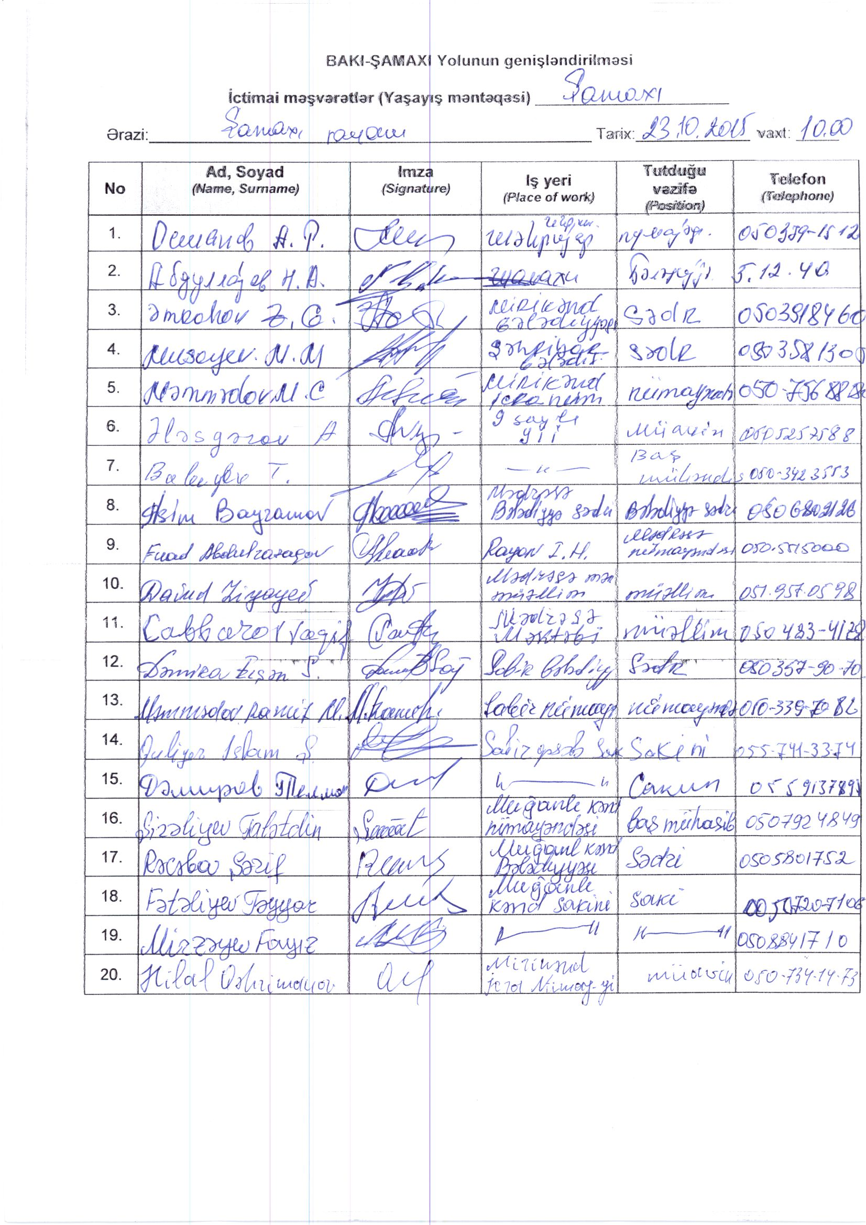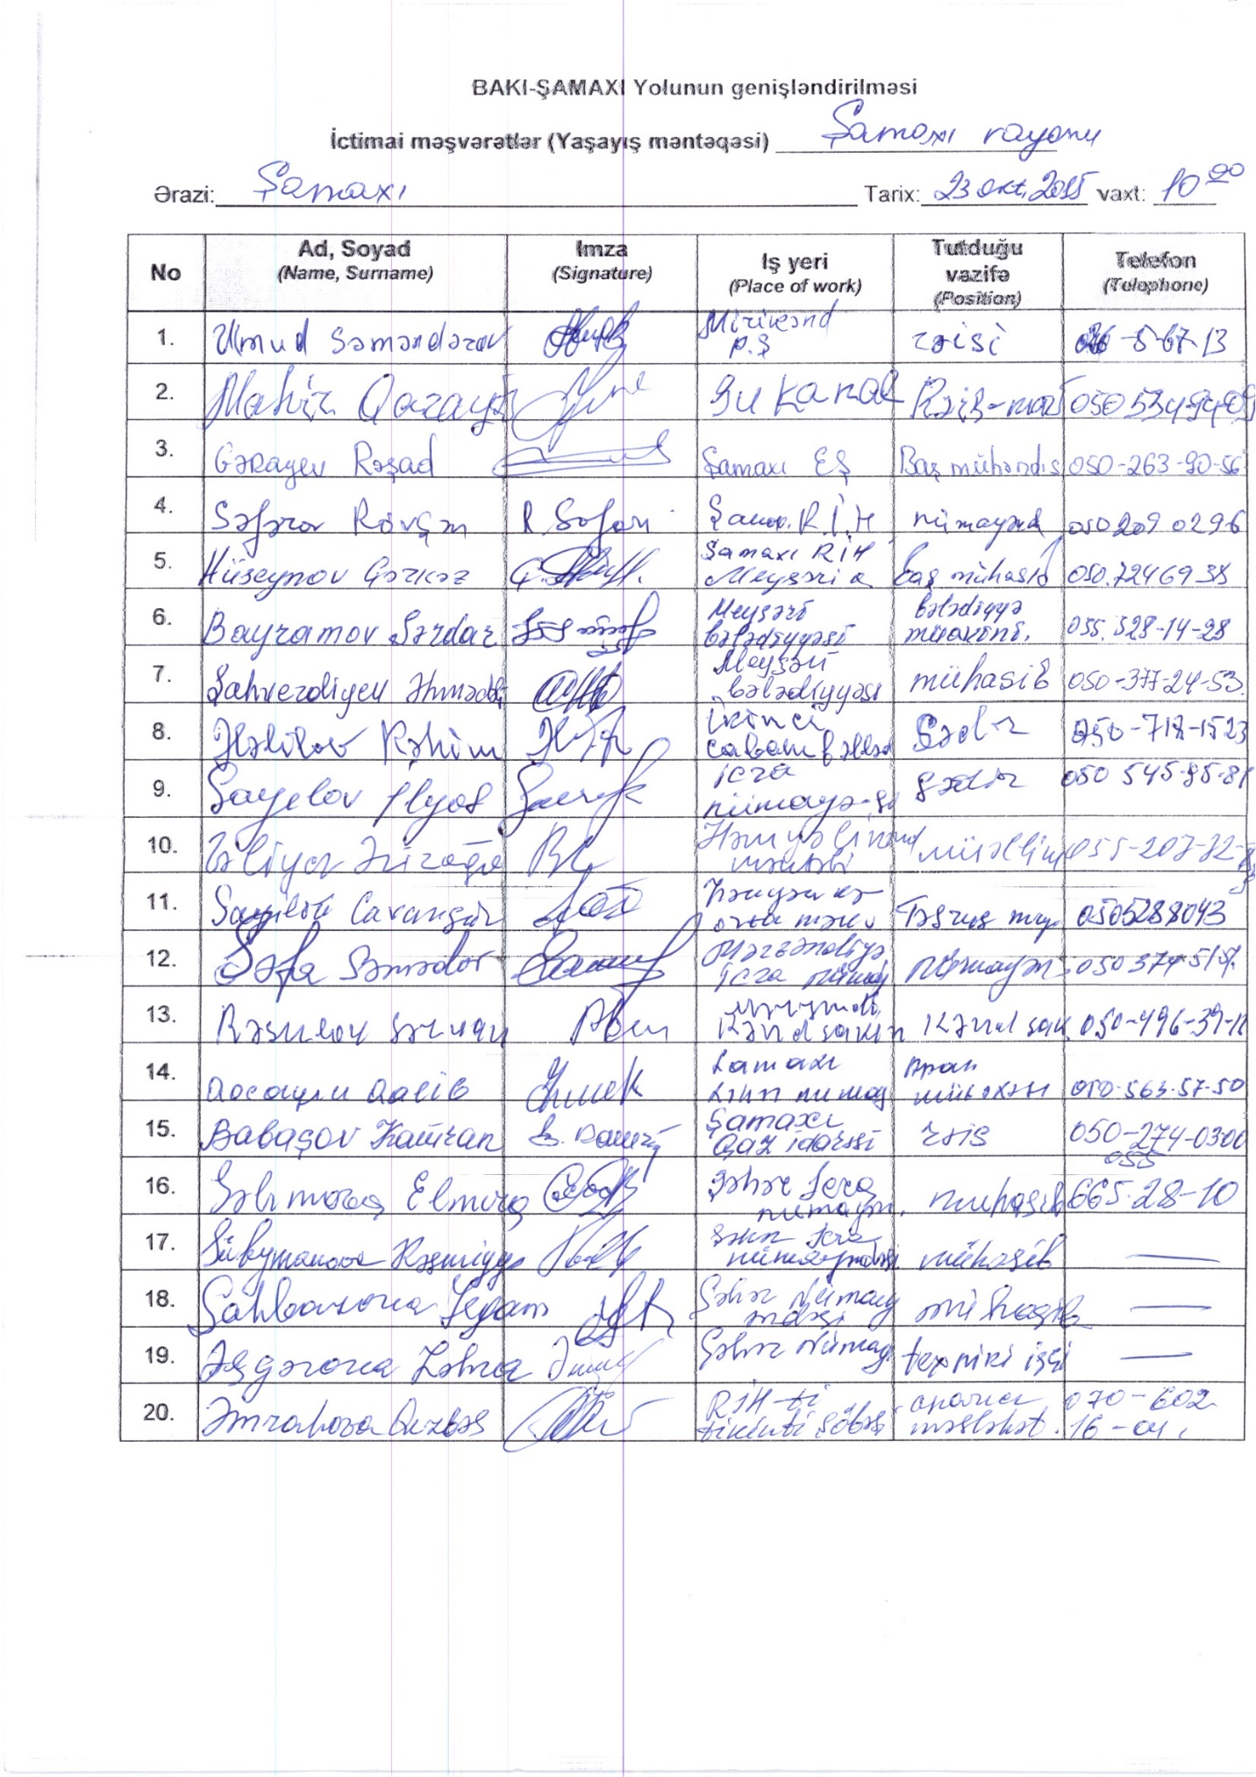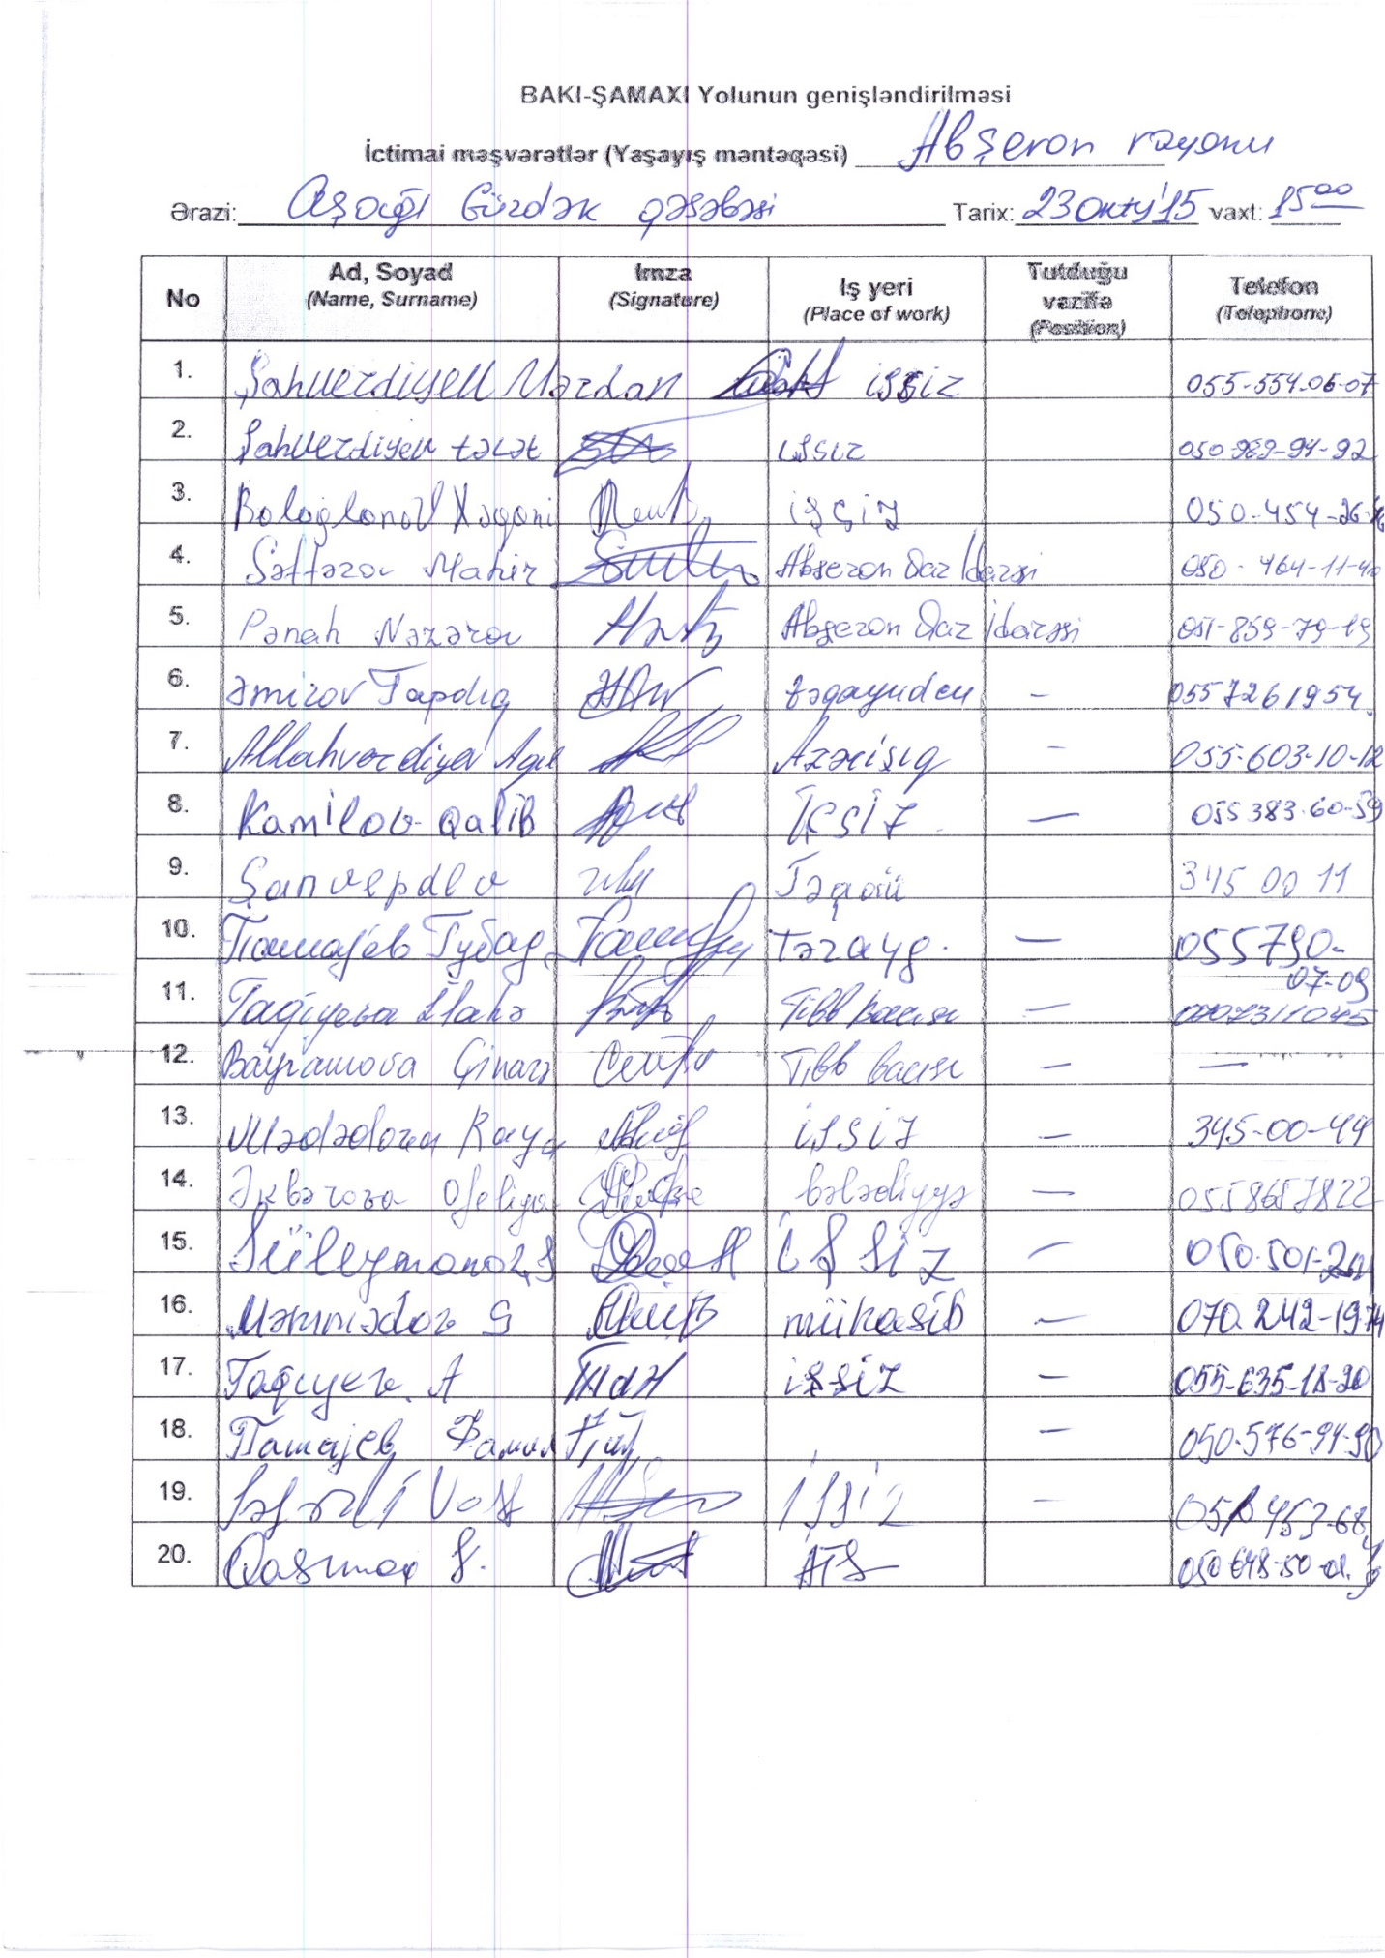

The possibility of the IDPs to be specifically affected by the project will be investigated during RAP preparation and appropriate measures will be defined
Additional costs may include but not limited to costs related to hardship, transportation, etc..
To be determined based on assessment of the market pries for respective agricultural products in the respective areas within the scope of RAP preparation works).
Based on the Labor Code of AR in case of termination of Labor Contract the Employee is entitled for three month compensation equal to three month salary to be paid by the Employer
This excludes compensation for squatted land. Compensation for squatted land will be paid upon decision of the court as per local legislation.
The local Police office which carries out review to attempt to locate the person. This includes identifying and interviewing his relatives, family members and friends, advertisement in the newspaper, among others. Based on this information local court based on the documents or request from the local authority representative announces the person missing and allows fund transfers to his account and the territory to be authorized for construction
LALSN, Article 81. Immunity from Taxation, Customs and Other Payments Tax, custom or any payments are not withheld from compensation for state interest in accordance with this Law.
e.g. 100 kg of yield per hectare.
Based on the official web site of the State Statistic Committee of AR officially accepted minimum salary is 105.5 AZN - http://www.stat.gov.az/source/labour/indexen.php This will be updated as necessary to reflect the official minimum salary at the time of RAP preparation.
EA stands for the Client, Azerroadservis, assigned by the COM at the beginning of the Project.

